ST LAWRENCE OF BRINDISI CATHOLIC PRIMARY SCHOOL
ZONING MAP

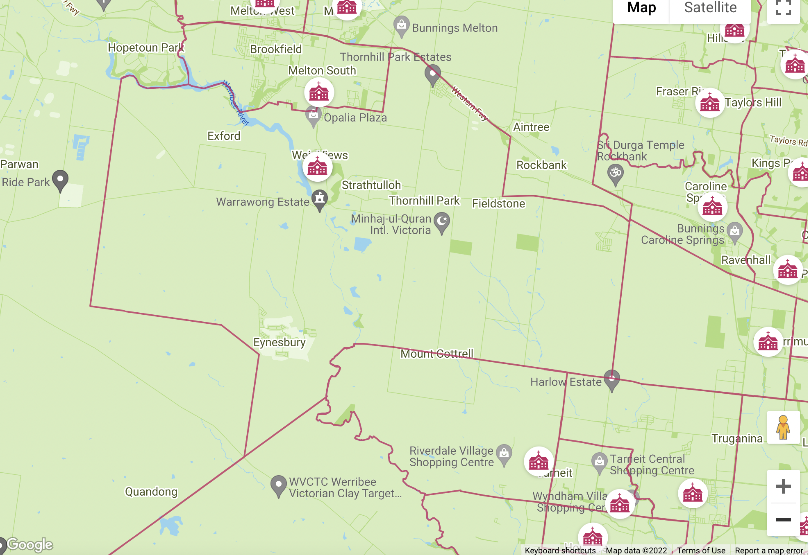
Zoning boundaries apply. Families living outside the school zone seeking enrolment will need to speak to the school leadership and will need a release letter from the Catholic school they are zoned to.

